ADP GlobalView®

Insight Dashboard:   
Consultant Guide

Commercial in Confidence

|  |  |
| --- | --- |
| Author | GlobalView Product |
| Document Reference | GV00009450 |
| Date | 2017/02/28 |
| Version | 2.0 |

##### Copyright and Confidentiality

Copyright © 2016 ADP, LLC. ADP Proprietary and Confidential – All Rights Reserved. These materials may not be reproduced in any format without the express written permission of ADP, LLC. This document must be kept strictly confidential at all times. It must not be disclosed to any person without the prior written consent of ADP, LLC.

ADP provides this publication “as is” without warranty of any kind, either express or implied, including, but not limited to, the implied warranties of merchantability or fitness for a particular purpose. ADP is not responsible for any technical inaccuracies or typographical errors which may be contained in this publication. Changes are periodically made to the information herein, and such changes will be incorporated in new editions of this publication. ADP may make improvements and/or changes in the product and/or the programs described in this publication at any time without notice.

The ADP® logo and ADP® letters are registered trademarks of ADP, LLC. GlobalView® is a registered trademark of ADP, LLC. iLearn@ADP® is a registered trademark of ADP, LLC. In the Business of Your Success(SM) is a service mark of ADP, LLC.

**Third-Party Trademarks**

Adobe® is a registered trademark and Acrobat™ is a trademark of Adobe Systems Incorporated.

Microsoft®, Windows®, Internet Explorer®, Word®, and Excel® are registered trademarks of Microsoft Corporation.

SAP® and SAP® R/3® are registered trademarks of SAP AG in Germany and in several other countries.

All other trademarks and service marks are the property of their respective owners.

##### Authorizations and Amendments History

| Version | Authored | Approved | CRM Ticket | Next Review Date |
| --- | --- | --- | --- | --- |
| 1.0 | 2015-12-10  Srini Cherlavancha  Solution Architect | 2015-12-10 |  |  |
| 1.1  Inclusion of HR Analytics Features | 2015-23-11  Srini Cherlavancha  Solution Architect | 2016/02/02  Srini Cherlavancha  GVAA0417 | 2014418703 | As Required |
| 1.2  FY16-Q04 Updates | 2016-06-20  Srini Cherlavancha  Solution Architect | 2016/06/20  Srini Cherlavancha  GVAA0417 |  | As Required |
| 2.0  New Version | 2017-02-28  Srini Cherlavancha  Solution Architect | 2017/02/28  Srini Cherlavancha  GVAA0417 |  | As Required |

##### Table of Contents

Terminology 5

Overview 6

Solution Details 7

Architecture 8

Reporting Database: 9

Personas 10

Application Overview 11

Configuration 13

Client Independent Configuration 13

Template Wagetype Mapping 13

SRF Components Assignment 14

Output Data Sets 14

Client dependent Configuration 15

Parameters Setup 15

Additional Data Fields 17

Client wage types mapping 18

Country Payroll Source 19

Define Manager Users 19

Managers Delegation 20

Control/Administrative Data 20

Client Output Data Sets 21

User Authorizations 22

Sub-categories Definition 23

Sub-categories Mapping 24

Exchange Rates 25

Sub Regions & Countries mapping 25

Age & Seniority – Brackets 26

Portal Users Mapping 27

Enable Dashboard Services 27

Define Insight Dashboard Users 28

Data Extraction 29

Extraction Process 29

Extraction Scenarios 29

Extraction Format 30

Aggregation and BW Data Load Process 33

Extraction Job Scheduler 34

Scheduling Extraction Job Scheduler 35

Extraction Reconciliation Report 36

Dashboard Tools 37

Wage Types Reconciliation 37

Governance 38

ITS Set-Up Tasks 39

1. Verify if the source system properly configured in BW system 39

2. Configure 3rd Party Logout URL 39

Responsibility Matrix 40

# Terminology

|  |  |  |
| --- | --- | --- |
| GV | GlobalView |  |
| GV | GlobalView |  |
| GVS | GlobalView- Streamline Integration | (Previously ‘GlobalView Select’) |
| SRF | Standard Return File | Streamline Return File (format) input to GlobalView system(S1 cluster) through G2 interface |
| BW | Business Warehouse | BW Reporting Database |

# Overview

ADP GlobalView Insight Dashboard is a self-service ad-hoc reporting solution for business users to analyze payroll data, create dashboards and reports. Data is gathered for GlobalView and Streamline countries and is consolidated into a single repository. Clients can use this repository and Insight Dashboard to compare workforce costs across countries, spot trends and gain insights to make strategic decisions.

GV Insight Dashboard is built on a third party reporting platform called Logi Analytics Business Intelligence platform and can be accessed from Revolution Self- Service portal.

The purpose of this document is to supply the steps required to configure the GlobalView Insight Dashboards solution. The document explains the components involved in the solution and provide technical implementation steps for the solution.

The audiences for this document are the GlobalView Implementation/Service Consultants responsible for Implementing & Supporting the Insight Dashboards solution.

|  |  |
| --- | --- |
|  | *The target users for the GV Insight Dashboard application are the Executive, business users and Manager users and the application can only be accessed via the ADP Portal. This means that the users MUST be set up on GlobalView as a portal user for them to be able to access the application.*  *For clients where the users resides in a country that has not been implemented on GlobalView, the user must be set up as ‘External Managers’ following the GlobalView External Manager solution (see* [*GV00003434 Global Product Template Document*](https://portal211.globalview.adp.com/sap/bc/bsp/sap/zadp_viewdoc/viewdoc.htm?ID=GV00003434) *4.6.2 ‘Manager in Another Country’ for further detail.)* |

# Solution Details

The GV Insight Dashboards application is the Front-end User Interface built on the Logi-Analytics Business Intelligence platform. This GV Reporting platform developed using the 3rd party reporting suite provides enhanced reporting environment and dashboards accessible through portal browser.

The dashboard provides the end user with a number of flexible options to suit their own individual needs. The users can customize the entire application using the available data sets. It is entirely at the user’s discretion what information is shown on the dashboard. The user can also drill down into each of the charts & segments to view the underlying data. The underlying data is presented to the users using the Analysis Grid which also provides a number of data manipulation options.

Once the end user has structured the dashboard to suit their own individual needs, the dashboard is saved against their own user ID on the web server. When the user comes back into the application at a later stage, the initial landing page will be the same as the user setup.

GV Insight Dashboard uses monthly snapshot of wage type level data for GlobalView Payroll and SRF component level data for Streamline Payroll. Regardless of the pay frequency, payroll results for a month are consolidated based on the pay period end dates. Data is available for the rolling 12 months and is presented to the user based on the calendar month(s) selected.

The Insight Dashboard comes with pre-configured values so that a set of standard metrics can be offered to all clients and they can use it with minimal implementation efforts.

The wage components (Wage types and SRF codes) are broadly classified into five categories:

1. Gross Wages
2. Employee Deductions
3. Net Pay
4. Employer Contributions
5. Other

Client users can sub categorize these pre-delivered categories and map the wage components to sub categories so that the workforce costs can be analyzed at desired levels of granularity.

## Architecture

The Insight Dashboards solution consists of a number of components that work closely with one another. The following diagrams illustrate all components and how these components interact with one another.

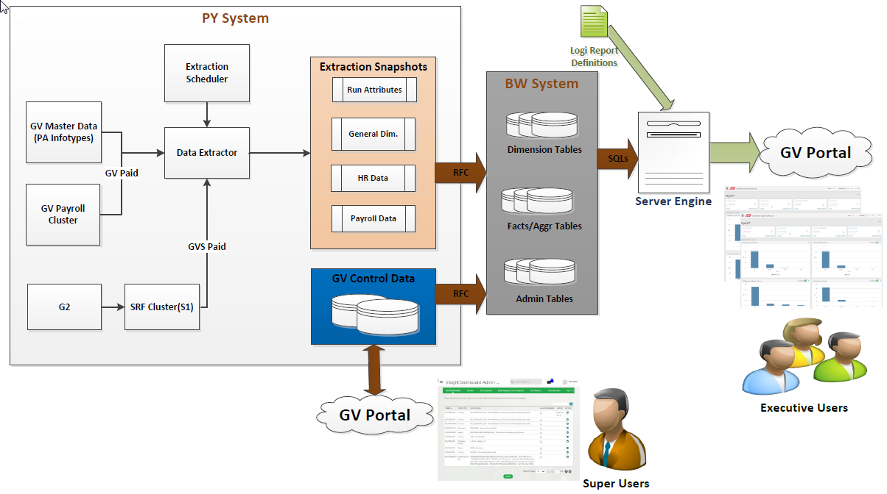

The important step in this solution is the Data extraction process which involves the extraction of the employee master and payroll data on a per-period basis and store into the period snap shots tables. The periodicity is same as the payroll frequency (e.g. weekly, fortnightly, monthly etc.). This will read the pre-configured employee basic master data and the payment information. The extractor is also able to read the additional supplementary master data as per the customer requirements.

There are three extraction scenarios based on the Payroll is processed by the GV or outside GV.

**Scenario 1 - GlobalView Paid:**

This scenario covers where the GlobalView is the system of record and employees are paid by GlobalView payroll engine. In this scenario master data is read from PA infotypes and payroll results read from PY clusters stored in GlobalView.

**Scenario 2 – GVS Paid:**

This scenario covers where the GlobalView is the system of record and employees are paid by Streamline partner network. In this scenario the employee pay results from streamline partners are interfaced back to GV and stored into GVS specific S1 cluster. The master data is read from PA Infotypes stored in GlobalView but whereas the payroll results should be read from GVS S1 cluster.

**Scenario 3 – HR Only:**

This scenario covers where the GlobalView is the HR System of Record and payrolls are not being processed by ADP. In this scenario ONLY PA Master Data is read and stored in the period snapshot database.

### Reporting Database:

Insight Dashboards is a Dashboards and Analytics tool and interacting with complex payroll database may cause the performance delays. A separate Reporting Database – BW System introduced into application architecture so that the Insight Dashboards underlying platform can natively interact with the BW system to fetch data for reporting with faster response times.

The BW system is a separate database cluster and it consists of individual instances corresponds to each system in GV payroll landscape as below. The data is transferred between GV payroll and BW systems through Remote function calls and same payroll system client identifier (MANDT) is used in BW system as well.

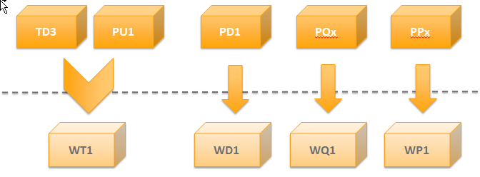

The extracted data in GV Payroll system to be loaded into this BW database to make this data available for reporting and the extraction programs have been built in such a way that the data transfer or replication happens during the extraction process itself. So the BW system works like a ‘**Black box**’ for implementation and client’s user means the teams shouldn’t be worried about the data processing and handling in BW system.

More details about the transformation and replication in BW system is provided in the ‘Data Extraction’ section.

## Personas

There are two primary client users for Insight Dashboard:

**End Users:** HR Business Partners, Shared Service team members, Business Analysts and Managers. They can use Insight Dashboard for data analysis and to create their own charts and dashboards. Through the analysis and visualizations they can quickly answer questions such as:

* Which countries have the highest payroll and benefits costs?
* What is the Overtime trend at a specific business site?
* What is the total workforce cost per FTE (Full Time Equivalent)?

**Administrators or Super Users:** This class of users will control the behavior of the application for the needs of their ‘End Users’. They can hide data fields in the application and modify labels so that the data elements reflect the business terms. These users can also map the individual country wage components (wage types/SRF codes) into sub categories, maintain currency exchange rates and distribute targeted reports to their End Users.

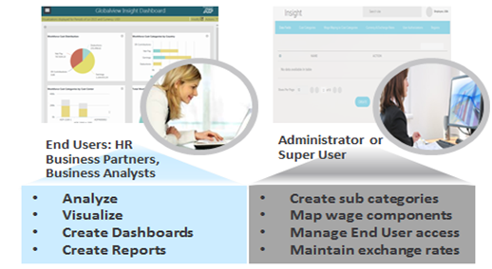

## Application Overview

This application can be accessed from GlobalView Self-service Portal mega menu under the Reports item and on its launch the users are presented with following home page.

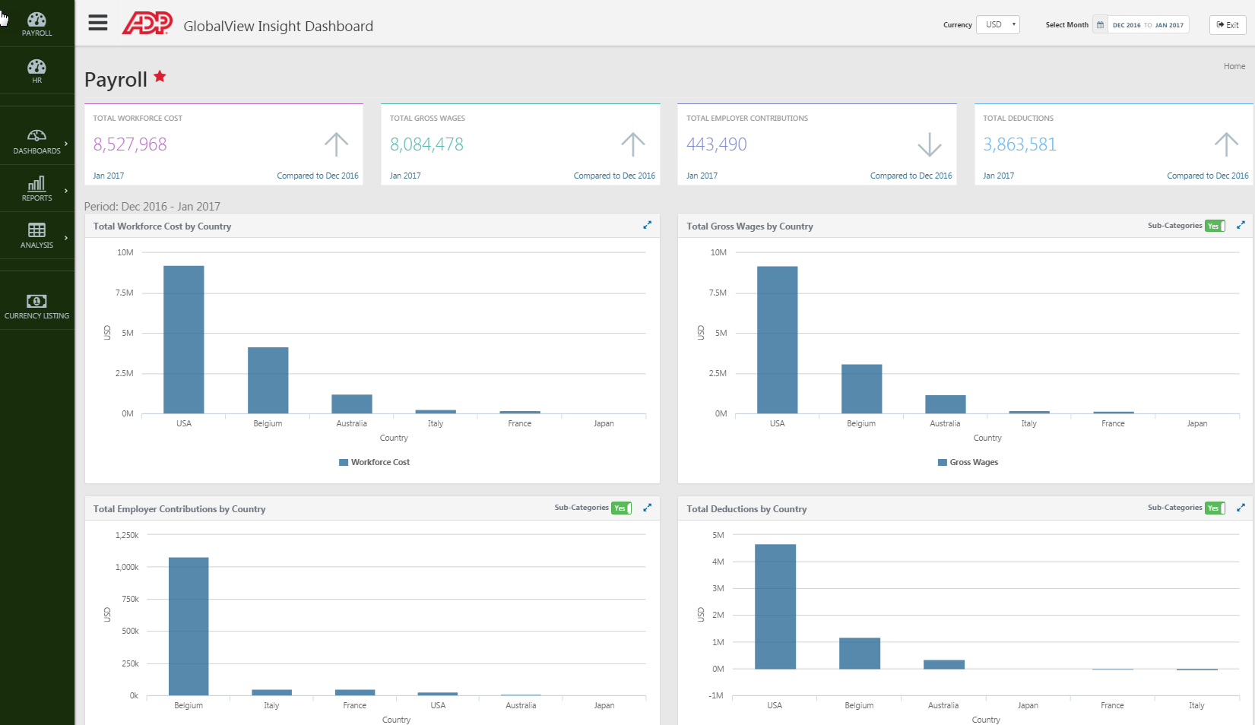

The Insight Dashboards solution consists of the following components:

##### Managed Payroll Dashboard:

This is pre-configured payroll dashboard that is presented to every user by default showing the Workforce costs distribution using the KPIs and series of charts:

1. Total Workforce Cost
2. Total Gross Wages
3. Total Employer Contributions
4. Total Deductions

The first section provides these key Payroll KPIs for the last month in the selected period and shows the increase or decrease in values compared to the previous month.

The second section providesdistribution of workforce costs across these standard categories by countries for selected period.

##### Managed HR Dashboard:

This HR dashboard is also pre-configured, shows the distribution of Employee count using the KPIs and series of charts.

The first section provides the key HR KPIs like Employee Count, FTE, New Hires and Leavers for the last month in the selected period and shows the increase or decrease in values compared to the previous month.

The second section displays the distribution of employee count by countries for the selected period in a series of charts:

1. Total Employee Count by Country
2. New Hires by Country by hiring reasons.
3. Leavers by Country by leaving reasons
4. Seniority or Age Group distribution by Country

##### Self-Service Dashboards:

Users will have the ability to create their own dashboards and save them for later use using this feature. They can include additional charts from visual gallery to the dashboards. Users can organize their dashboards in folders for re-use. A built in search capability offers quick access to relevant dashboards within the folders.

##### Self-Service Reports:

The users can create professional looking management reports quickly with the intuitive features like drag and drop charts, add text and logos. The reports can be downloaded in PDF format for distribution to management.

##### Self-Service Analyses:

End users can analyze the data using the application’s inbuilt MS Excel like capability to easily sort, group, aggregate, filter and apply formulas. The analysis can be saved in user defined folders for later use. The built in search functionality offers a quick way to search the relevant analysis within the folders. Users can visualize the data in multiple formats like Pie chart, Bar chart, Line chart and save them to visual gallery repository for using in dashboards. Users can also download the data in Excel, CSV or PDF format.

# Configuration

The following sections contain the details on the Insight Dashboard Configuration requirements and the individual components used in the solution.

All the Insight Dashboard configuration components can be accessed through the area menu **ZGVI**.

## Client Independent Configuration

**Note:** The client in-dependent configuration is maintained in the Template system as part of the solution design. These are just mentioned here for reference and don’t require any changes at the client level.

### Template Wagetype Mapping

**Table: ZVADP_GID_GWGTYP**

The Insight Dashboard solution comes with the pre-defined mapping of wage types to be extracted and displayed in the application for all the GlobalView payroll countries. So that the solution can be implemented with minimal efforts and users can directly start with checking the extraction process output.

It should be expected that all the pay components displayed with the template payslip PE51 form are mapped here and the wage types mapping is done with cumulation, evaluation classes so that any new/ custom wage types are automatically part of the extraction mapping.

The application displays the wage components at five broader wage categories and so all the wage types are mapped to any of the below category.

1. Gross Wages
2. Employee Deductions
3. Net Pay
4. Employer Contributions
5. Others

This Wage types mapping is maintained at the country level alongside the Report name. The report name can be used to create multiple set of parameters. The template report name used for all the countries is ‘/DEFAULT’.

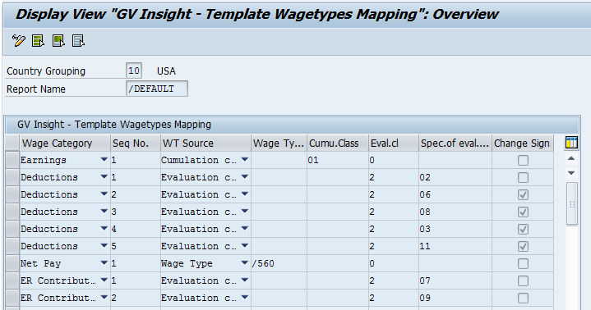

### SRF Components Assignment

**Table: ZXADP_GID_GSRFCT**

For the Streamline paid countries; the pay information is extracted from the SRF cluster and to group them into the standard wage categories, all the SRF pay components to be extracted are mapped to the specific Wage category in this table.

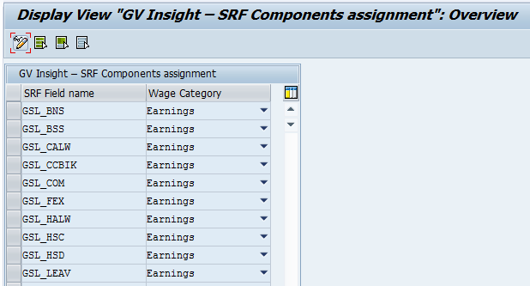

### Output Data Sets

**Table: ZVADP_GID_OPDSET**

The Data sets corresponds to the collection of the data presented in the application based on its attributes. The below are the output datasets available to the users through the application to perform the analysis and visualization.

* **G1 – General Dimensions**
* **H1 – Employee Demographics**
* **P1 – Payroll Details**

All the fields are configured in this table with respective field description and sequence for all these three data sets. These fields can be configured at client level as per the client requirements which will override the template field attributes.

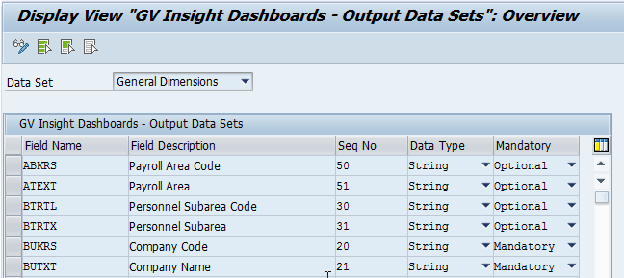

## Client dependent Configuration

* The client specific configuration is ONLY required if the standard template setup is not suitable for client requirements and if the client requires additional customization.
* If the client configuration is required then it should be maintained before performing the data extraction otherwise it could lead into the re-extraction of the data.

These components can be accessed through the area menu **ZGVI 🡪 Configuration 🡪 Client Dependent Setup.**

### Parameters Setup

**Table: ZVADP_GID_PARAMS**

For GV Insight Dashboards, it is required to set up various parameters at client and country level to decide on the set of values to be used for extraction and reporting.

The parameters names are fixed based on the applications requirements and it should be maintained with the specific country grouping if it is country dependent and if it is independent of country then values should be maintained against the country grouping ‘99’.

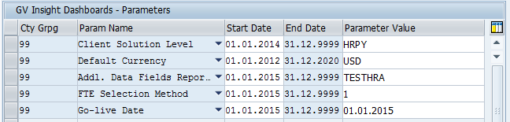

These parameters have the default values to be used in the application if it is not maintained at the client level. The below are the important parameters to setup and its usage.

1. **Client Solution Level:** The solution level to be chosen at the client level to support the HR and Payroll data metrics. The extraction of data and display of metrics in portal are based on this setup. Any one of the following solution levels to be configured at client level for country grouping 99.

**HR - HR Only:** Only HR Master Data (PA Infotypes) is extracted in the backend and only HR data metrics/dashboards are displayed in the application features.

**PY - Payroll Only:** Only General Dimensions and Payroll results are extracted in the backend and displayed in the application features.

**HRPY - HR and Payroll: Both HR Master Data and PY results are** extracted in the backend and displayed in the application features.

* The default solution level is **HRPY - HR and Payroll** if nothing is configured at client level.

1. **FTE Selection Method:** The FTE(Full time equivalent) calculation method can be varied at client level and it can based on various parameters capacity utilization, employment percentage etc.,

The following FTE calculation methods are available to be configured at client level.

**‘1’ - Capacity Utilization Level**: Based on Infotype 0008 capacity utilization level

**‘2’ - Employment Percentage**: Based on Infotype 0007 Employment percentage

**‘3’ - Weekly Work Time Percentage**: Based on weekly working of the collective agreement.

* The default FTE Calculation method is ‘**1**’ – Capacity utilization level if nothing is configured.

1. **Go-live Date:** First country Go-live date should be maintained for the country grouping ‘99’ and the following countries dates to be maintained against specific country grouping. The data extraction is performed starting from the Go-live date.

* If nothing is configured then data extraction can be performed for any period if the pay results are available.

1. **WTs mapping Report Name:** The report name to read the WTs mapping during the extraction to be maintained against this parameter ONLY if it is other than ‘/DEFAULT’.
2. **Additional Data Fields Report Name:** The custom fields mapping report name to be maintained against this parameter ONLY if it is other than ‘/DEFAULT’.
3. **Maximum Sub-categories:** This is to configure the maximum number of sub-categories definitions to be allowed from the super user screen. By default it is **limited to 10** keeping in mind the challenges of manageability and user experience. **It should NOT be changed without written consent from product owner or solution architect.**

### Additional Data Fields

**Table: ZVADP_GID_CSFLD**

As explained in the earlier section, the extraction process extracts the pre-defined employee basic master data fields to display in the application. It is also made possible to configure the additional master data fields as per the client requirements in-addition to the standard fields.

There are additional fields CUST01 – CUST12 defined as part of the HR Extraction set and these can be used to display any other master data information which is not part of the standard extraction set. These fields can be configured to display fixed value or infotype field value.

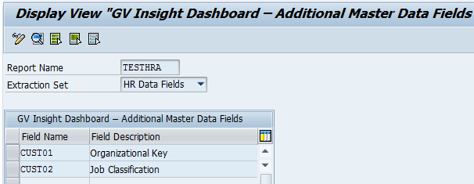

The additional master data fields can be configured as below.

**Field Name:** The custom field name used to hold the additional master data information.Only fields CUST01 – CUST12 are allowed to be used to configure for the additional master data.

**Field Description:** The customer field description or label to be displayed in the application.

**Default Value:** If the fixed field value to be displayed for all the employees then that particular value to be maintained here.

**Infotype/Field name:** If the value to be extracted from the infotypes then the corresponding technical details like Subtype, Fieldname to be maintained here.

**Read Field Value Text:** If infotype field text to be extracted instead of the value then this field should be flagged.

**Exit Class:** If the extraction logic is complex which requires multiple conditions then Exit class can be created with required programming logic and the same to be maintained here.

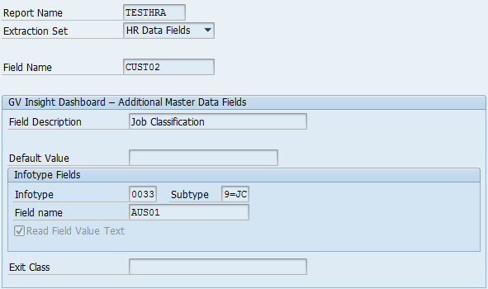

### Client wage types mapping

**Table: ZVADP_GID_CWGTYP**

If the client requirements don’t satisfied with the template wage mapping for the country then the client specific parameters can be maintained in this table. Again all the pay elements or wage types to be extracted should be maintained here. Here also the wage components can be maintained using the cumulation class, evaluation -class and direct wage types.

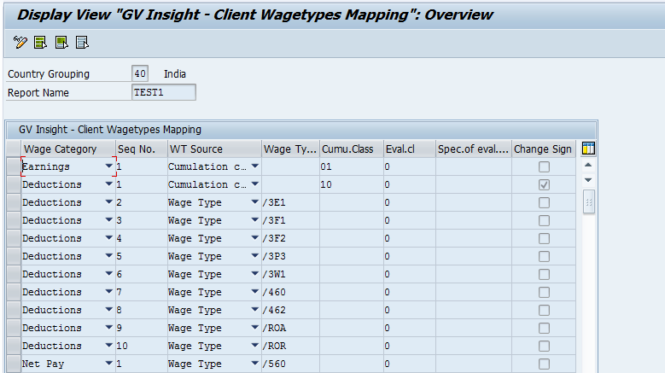

The custom wage types mapping can be maintained same as template parameters as below.

**Wage Category:** The category of the wage component to be chosen from the available Earnings, Deductions, Net Pay and Employer Contribution’s.

**Sequence No:** The display sequence number of the wage components within the same category.

**WT Source:** The source is to determine the wage components. It is possible to configure with the direct Wage types, Cumulation class or the Evaluations classes.

**Wage Type:** If any wage types are fixed like the /560 for Net pay can be maintained directly. This field is only active if the WT source is selected as ‘Wage Type’.

**Cumulation class:** The cumulation classes from 01 – 99(WT /101 - /199)are allowed to maintain based on the availability for specific country. If the cumulation class is maintained then all the WTs cumulated into that specific secondary wage type are included into the wage category and then extracted for output.

**Evaluation class:** The wage components can also be maintained using the evaluation classes similar to the PE51 configuration. The allowed evaluation classes from 01 – 20 based on the country can be maintained here.

**Specification of evaluation class:** The value of the selected evaluation class should be maintained here. Like the 01 evaluation class with specification as D0.

**Change sign:** If the wage component values to be displayed with opposite sign then this field should be flagged. Like deductions with negative sign to be displayed positive values.

### Country Payroll Source

**Table: ZVADP_M99_PYPRT**

The Insight Dashboard application requires identifying the countries payroll processed by the streamline partners so that the payroll results can be extracted from SRF S1 clusters instead of GV payroll results.

So all the countries payroll processed by the streamline to be maintained in this table and if the countries are not maintained in this then application considers them as GV paid countries.

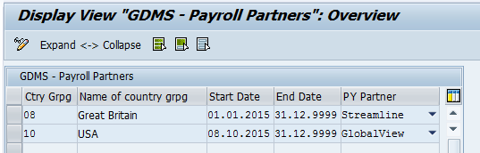

### Define Manager Users

**Feature: ZGIUS**

This feature has to be configured if the Insight Dashboards access has to be provided for the manager users to allow viewing their sub-ordinates data through the application. The managers’ access can be enabled based on certain Organizational Assignment fields.

There are two options in the feature return value:

* X: This manager can use the Insight Dashboards
* Space: This manager can't use Insight Dashboards

By default, the return value is space which means that Insight Dashboards it not enabled for the managers access at all.

The following decision fields in the feature can be used to provide the managers access for the various combination of fields.

* MOLGA: Country Grouping
* BUKRS: Company Code
* WERKS: Personnel Area
* BTRTL: Personnel Subarea
* PERSG: Employee Group
* PERSK: Employee Subgroup
* ABKRS: Payroll Area
* KOSTL: Cost Centre
* JUPER: Legal Person
* VDSK1: Organizational Key

**Note**: If the managers access to be provided for the group of managers then this feature can be configured accordingly, But if the access has to be provided for very few specific users then it can be done through the User Authorizations in the Super user menu (explained in the following sections).

### Managers Delegation

Managers User access can be delegated to the administrative assistants so that they can run the application and perform the analysis for the employee’s reports to their manager. This is mainly useful for senior managers to delegate their access and so that delegates so that these delegates can run the reports and examine trends etc. on the behalf of the managers.

Insight Dashboards manager’s access can be delegated to the manager subordinates in the User Authorizations by assigning the manager employee id to delegates employee id.

**Note: This is further explained in the Control data section.**

## Control/Administrative Data

This is the client level setup to customize and control the data flow in the Insight Dashboards application. All these control tables are available for the client administrators or super users to maintain from the portal admin console application. This eliminates the need for super users to log into the SAP GUI to perform these tasks.

Embedded Document: [GV00009449 Insight Dashboard Admin User Guide](http://teamsites.adpcorp.com/Sites/ProductTeamHomepage/insight-dashboard/SitePages/Home.aspx)



**Notes:**

* These tables can also be maintained from R/3 system during the solution implementation as these have been delivered as the application tables.
* All these tables are delivered with the default entries from the template as part of the solution and then these can be adjusted as per the client needs.
* The data extraction process is de-coupled from these Administrative functions to allow the clients to modify their configuration over time according to their evolving business needs without having to re-extract the data.

These components can be accessed through the area menu **ZGVI 🡪 Control Data.**

### 

### Client Output Data Sets

**Table: ZVADP_GID_CLDSET**

This is to control the Output data sets fields’ visibility and rename the field labels to reflect the client business terminology. This table also allows overwriting of the field label, Sort sequence and default visibility of the fields that comes from the template setup.

The below are the output datasets considered in the various analysis and visualization sections in the applications.

* **G1 – General Dimensions**
* **H1 – Employee Demographics**
* **P1 – Payroll Details**

**Note: This table comes with default entries from template and then it can be overwritten as required.**

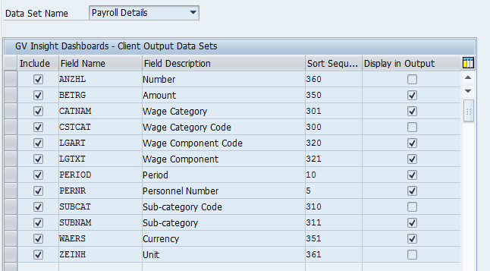

The following are options available with this table.

**Include:** If this is flagged as ‘X’ then only the particular field is displayed in the application and if any of fields to be excluded from being displayed in the application due to the sensitivity of the information at the client level then this shouldn’t flagged.

**Field Name:** The technical field name from the standard output data set.

**Field Description:** The field description can be maintained as per the client’s business terminology which will overwrite the template description.

**Sort Sequence:** This can be maintained with the display sequence of the field in the application output which will again overwrite the template sort sequence.

**Display in Output:** If this field is flagged then field is displayed by default in the output otherwise field is to be chosen from the settings in-order to display it in the output.Sub-categories Definition

### User Authorizations

**Table: ZVADP_GID_USRAUT**

This User Authorizations mapping table is used to assign GV Insight Dashboards users to a specific area of responsibility. The available options include the following:

* M – Country
* B - Company Code
* W - Pers. Area
* P - Pers. Subarea
* G - Employee Group
* R – Region
* S – Sub region
* V – Manager
* D – Delegation

Each user who is authorized to use the GV Insight Dashboards application should be assigned to one of the above along with the respective authorization values for the respective category.

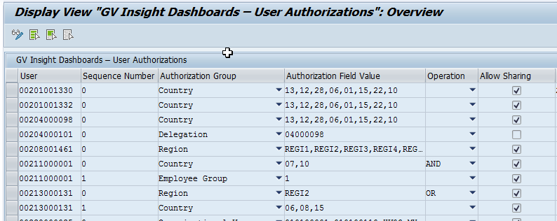

**Operation:** This enables to provide the complex authorizations to End users using the AND, OR logical operators. Like if the access has to be provided only for permanent employees of some countries then AND operation should be used to combine the Country and Employee Group records. Similarly if any user authorization has to be given to all countries in a Region but few specific countries in other regions then OR operation should be used to combine the Region and country records.

**Sharing:** The sharing feature allows the End users to share their work with other users. Then the recipient user can use them without having to create them by themselves. Individual dashboards, reports and analysis can be shared as well as the folders that contain this content.

The Insight Dashboards Sharing feature is activated for all the clients by default. Then Insight Dashboards Admin or Super users can authorize the individual End users to allow for sharing through the ‘User Authorization’ Tab in Admin console. This option is also available through the R/3 screen as shown in above screen shot.

The recipient user can access all the shared items and these shared items can’t be edited. But the user can duplicate them and then able to make the changes to duplicated items as required.

**Note:** The sharing feature enables only the layout and report formats to be shared. But the data in the shared items is still based on recipient user authorizations.

**Manager User:** As explained in the previous sections; the manager users also can be provided with the application access to analyze their sub-ordinates data. If the access has to be provided for the group of manager users then the feature can be configured accordingly. But if the access has to be provided for few specific users then this table can be maintained for the specific manager user and authorization group as ‘Manager’.

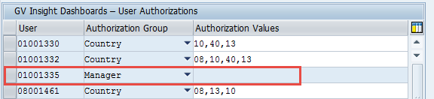

**Delegation:** Managers User access can be delegated to the administrative assistants so that they can run the Insight Dashboards application and perform the analysis for the employee’s reports to their manager. This delegation access can be provided by assigning the manager employee id to delegate’s employee id with authorization group as ‘Delegation’.

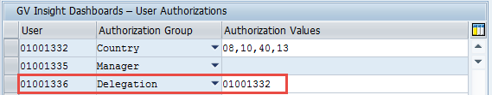

In the above example Manager User 01001336 access is delegated to his subordinate user 01001332 so that this user can access the reports on behalf of manager.

### Sub-categories Definition

**Table: ZVADP_GID_COSCAT**

As explained in the earlier section; the application by default display the wage components in five broader categories and these can be sub categorized so that the workforce costs can be analyzed at desired levels of granularity as per the client business needs.

**The below sub-categories definition is provided default from template and additional sub-categories can be defined as required. These sub categories have been intentionally limited to 10 keeping in mind the challenges of manageability and user experience.**

1. Gross Wages

* Salary
* Benefits in kind
* Allowances
* Overtime
* Bonus

1. Deductions

* EE Taxes
* EE Social Contributions

1. Net Pay
2. ER Contributions

* ER Taxes
* ER Social Contributions

The additional sub-categories can be defined in this section by giving the technical name, description and assigned it to a standard category.

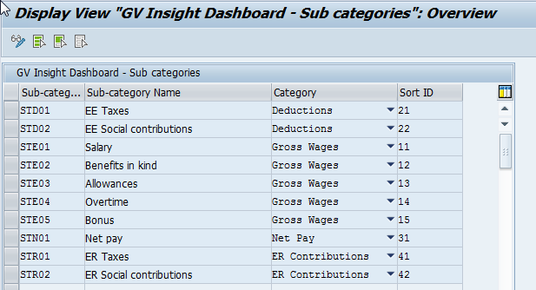

### Sub-categories Mapping

**Table: ZVADP_GID_CSTCMP**

In this all the extracted WTs to be mapped to the respective sub-categories defined in the previous section at country level. The SRF components to be mapped in case of the GVS country.

Note: This table mapping doesn’t come from template as the wagetypes largely varies from client to client.

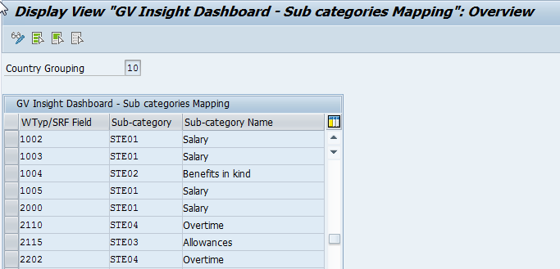

### Exchange Rates

**Table: ZXADP_GVD_TCURR**

The exchange rates table is used to define the exchange rates between currencies. The exchange rate type GVD is used to define the exchange rates for the Insight Dashboards application.

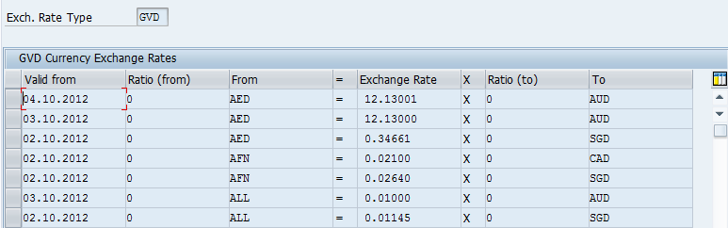

Note: It is mandatory to have the exchange rates maintained for the Rate type GVD to support the currency conversion functionality with the Insight Dashboards application.

G2 record type TCURR can be used to load the exchange rates with G2/SSL.

### Sub Regions & Countries mapping

**Table: ZVADP_GID_SUBREG**

The insight Dashboards application allows the geographical grouping and reporting of the data above the country using the Region and sub-region fields.

The geographical regions are pre-fixed with the following five regions.

1. REGI1 – Africa
2. REGI2 – Americas
3. REGI3 – Asia
4. REGI4 – Europe
5. REGI5 – Oceania

Then the Sub-regions can be defined under these 5 regions at client level with the desired levels of granularity as per the client business needs. The default sub-regions definitions come from template and then it can be overwritten at client level as required.

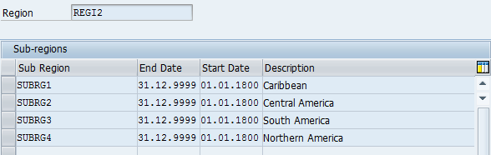

Finally the countries should be assigned to the respective sub-regions as below.

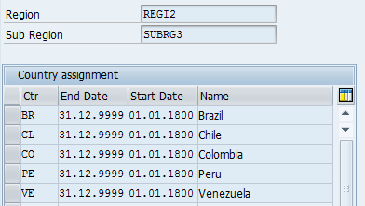

### Age & Seniority – Brackets

**Table: ZVADP_GID_YRGRP**

The Age and Seniority Brackets determine the brackets that should be used to group the years for displaying the Age and Seniority pyramids. This table also comes with default brackets from template and then it can be overwritten at client level as required.

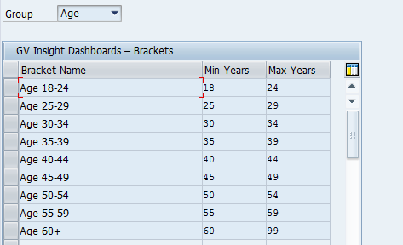

## Portal Users Mapping

GlobalView offers the Insight Dashboard application through the GV self-service portal for Client users. There are two kinds of Dashboard users: Executive user and Dashboard administrator. For the Super users, the additional backend role Z_XSS_ADP_GVD_SUPER to be assigned beside the standard XSS backend role Z_XSS_PORTAL_USER:

The ULP program has been enhanced to automatically recognize the user type and add these additional roles for the respective Dashboards user.

**User Mapping Configuration Details**

The following steps are required to be configured for the portal user mapping:

1. Enable Dashboard services in table ZXADP_M99_GV_APP
2. Maintain the users for Dashboard in the table ZXADP_M99_XSSGRP
3. Execute the ULP program for the users to update the backend roles for super user

These tables can be accessed through the area menu ZGVI 🡪 Portal user’s setup.

### Enable Dashboard Services

**Table: ZXADP_M99_GV_APP**

For any client that uses the Insight Dashboard application, the following portal group services should be enabled in order to display them through GV portal mega menu.

|  |  |
| --- | --- |
| Service key | Service Description |
| ZXADP_EXECUTIVE_INSIGHTDASHBOARD | Insight Dashboards |
| ZXADP_MANAGER_LOGIXML_INSIGHTDASHBOARDDF | Insight Dashboards Admin Console |

### 

### Define Insight Dashboard Users

**Table: ZXADP_M99_XSSGRP**

This table is to be maintained the personnel numbers who are the Insight Dashboard administrators or Executive users with the respective roles as below.

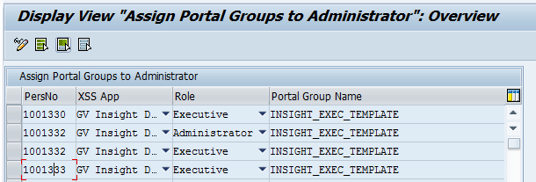

In the above example the employee 01001332 is both an Executive and an administrator whereas the Employees 01001330 and 01001333 are Executive Users only.

After enabling these services and assigning the user roles, The Insight Dashboards applications are displayed in GV portal Mega menu as below.

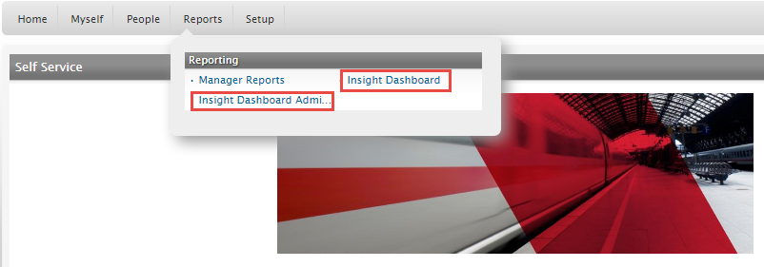

# Data Extraction

The extraction step reads the data from various sources based on the payroll scenarios and stores data as employee snap shots for each payroll period. The extraction can only be executed for each payroll area/period at a time. The Extraction scheduler helps to schedule the individual jobs for all the selected payroll areas/periods in one shot.

The BW Transactional Data Load program takes care of aggregating of this extracted data and upload to BW Database. As mentioned earlier, this can be automatically triggered with extraction process itself.

## Extraction Process

The Extraction process involves extraction of the employee master and payroll data on a per-period basis and store into the period snap shots tables. The periodicity should be same as the payroll frequency (e.g. weekly, fortnightly, monthly etc.).

The extraction process will read the pre-defined employee basic master data and the payment details. The extractor is also able to read the additional supplementary master data as per the customer requirements. The supplementary data fields and sources can be configured at client level using the customizing tables as described in the earlier sections.

**Note: The extraction of the GV Payroll results is based on the In-view and the In-period dates are considered as the extraction period dates.**

### Extraction Scenarios

There are three extraction scenarios based on the Payroll is processed by the GV or outside GV.

**Scenario 1 - GlobalView Paid:**

This scenario covers where the GlobalView is the system of record and employees are paid by GlobalView payroll engine. In this scenario master data is read from PA infotypes and payroll results read from PY clusters stored in GlobalView.

**Scenario 2 – GVS Paid:**

This scenario covers where the GlobalView is the system of record and employees are paid by Streamline partner network. In this scenario the employee pay results from streamline partners are interfaced back to GV and stored into GVS specific S1 cluster. The master data is read from PA Infotypes stored in GV but whereas the payroll results should be read from S1 cluster.

**Scenario 3 – HR Only:**

This scenario covers where the GlobalView is the HR System of Record and payrolls are not being processed by ADP. In this scenario ONLY PA Master Data is read and stored.

### Extraction Format

The extracted master data is stored into separate tables in Payroll system as General dimensions, Employee demographics and Payroll Details.

#### General Dimension Fields:

The following fields are part of the standard HR extraction fields and custom fields 01 -12 can be used to configure for the additional master fields at client levels.

| Field Name | Description | Comments |
| --- | --- | --- |
| PERNR | Personnel Number | Personnel Number |
| SEQNR | Sequence Number | Internal use |
| PERIOD | Period | End date of payroll period |
| ENAME | Employee Name | Formatted name of the Employee |
| PERSID | Global ID | Infotype 0709 ID |
| MOLGA | Country Grouping | Employee Country Grouping |
| INTCA | Country Code | Country ISO code(2 Char) |
| MLGTX | Country | Country Description |
| BUKRS | Company Code | From IT0001 |
| BUTXT | Company Name | Company Description |
| WERKS | Personnel Area Code | From IT0001 |
| PATXT | Personnel Area | Personnel Area Description |
| BTRTL | Personnel Subarea Code | From IT0001 |
| BTRTX | Personnel Subarea | Personnel Subarea Description |
| PERSG | Employee group Code | From IT0001 |
| PGTXT | Employee Group | Employee Group Description |
| PERSK | Employee Subgroup Code | From IT0001 |
| PKTXT | Employee Subgroup | Employee Subgroup Description |
| VDSK1 | Organizational Key Code | From IT0001 |
| VDSKTX | Organizational Key | Organizational Key Description |
| ABKRS | Payroll Area Code | From IT0001 |
| ATEXT | Payroll Area | Payroll Area description |
| ORGEH | Organizational Unit Code | From IT0001 |
| ORGTX | Organizational Unit | Organizational Unit Description |
| PLANS | Position Code | From IT0001 |
| PLSTX | Position | Position Description |
| KOSTL | Cost Center Code | From IT0001 |
| KOSTX | Cost Center | Cost Center Description |
| REGION | Region Code | Based on countries assignment |
| REGTXT | Region | Based on countries assignment |
| SUBREG | Sub Region Code | Based on countries assignment |
| SUBRTX | Sub Region | Based on countries assignment |
| CUST01 – 12 | Custom Fields 01 – 12 | Custom fields allowed to be configured at client level |

#### Employee Demographics:

| Field Name | Description | Comments |
| --- | --- | --- |
| PERNR | Personnel Number | Personnel Number |
| PERIOD | Period | End date of payroll period |
| MGRID | Manager ID | Manager ID from OM or MLT |
| MGRNAME | Manager Name | Formatted name of the Manager |
| IS_MGR | Position Type | Manager or Non-manager |
| GESCH | Gender | From IT0002 |
| GBDAT | Birth Date | From IT0002 |
| HIRED | Entry Date | Hiring Date |
| HRTXT | Hiring Reason | Hiring action reason description |
| HIRE | EE Hired | ‘1’ - if Employee hired in the period |
| FIRED | Leaving Date | Termination Date |
| FRTXT | Termination Reason | Termination action reason description |
| FIRE | EE Terminated | ‘1’ - if Employee terminated in the period |
| AGE | Age | From Birth Date |
| AGE_GRP | Age Bracket | Based on Brackets definition |
| SENIORITY | Seniority | From Hire Date |
| SENI_GRP | Seniority Bracket | Based on Brackets definition |
| STAT2 | Employment Status code | From IT0000 |
| STATX | Employment Status | Employment Status Description |
| EE_COUNT | Employee Count | ‘1’ – if the Employee is active |
| FTE | FTE | Full Time Equivalent |
| CONTRACT | Contract Type | Active IT0016 subtype description |

#### Payroll Details:

| Field Name | Description | Comments |
| --- | --- | --- |
| PERNR | Personnel Number | Personnel Number |
| SEQNR | Sequence Number | Internal use |
| PERIOD | Period | End date of payroll period |
| CSTCAT | Wage Category Code | Standard category |
| CATNAM | Wage Category | Standard category Description |
| SUBCAT | Sub-category Code | Custom category as per client setup |
| SUBNAM | Sub-category | Custom category description |
| LGART | Wage Component Code | Wagetype or SRF Component |
| LGTXT | Wage Component | Description |
| BETRG | Amount | Wage Amount |
| WAERS | Currency |  |
| ANZHL | Number | Payroll Number |
| ZEINH | Unit |  |

## Aggregation and BW Data Load Process

The Aggregation process involves the aggregation of extracted non-monthly results into the Monthly results and collecting the employee and wagetype levels data into various aggregated datasets. Then the aggregated data is sent the BW Reporting database for reporting.

The BW Transactional data load program reads the Employee snapshots stored in the extraction tables in Payroll system for each pay period and collected into the aggregated database table in BW database system once per month. The period data is aggregated into monthly values based on the period end date of each period stored within the period snapshot database table. For the off-cycle runs the off-cycle payment is considered for monthly aggregation. The aggregated values will be stored as monthly values for each calendar month.

The below are the various levels of aggregation and data is stored separately into each dataset.

1. General Dimensions
2. HR - Employee Details
3. HR - Aggregate
4. Payroll - Category Aggregate
5. Payroll - Wagetype Aggregate
6. Payroll - Employee Column Aggregate
7. Payroll - Employee Details

The below enclosed object details the list of fields available in each dataset.



As the BW system should work as black box for the users, this aggregation and BW load process can be triggered with Extraction process itself. So this aggregation step is not another action to be performed instead it is merged with Extraction step.

## Extraction Job Scheduler

The Extraction Job scheduler helps to schedule the individual extraction jobs for all the selected payroll areas and periods in one shot. The scheduler program check the availability of the payroll information for the selected period, identifies the Integration scenarios and then schedules the extraction program individually for each combination.

The option ‘**Schedule BW System Data Load**’ should always be checked to perform the aggregation and BW Load without any further actions.

**Transaction : ZRADP_GID_EXSCHD**

**Program** **:** **ZR_XADP_M99_GID_SCHEDULER01**

This program selections and flow logic as follows:

1. Accepts Month and Year as Input Parameters. Defaults to Previous Month.
2. Program has two processing options as below,
   1. GV Paid Employees
   2. GVS Paid Employees.
3. In case of GV Paid Employees
   1. Selects All Payroll Area, Payroll Type, PAYID and IPEND combination for the month from table HRPY_RGDIR (Payroll results Directory).
   2. Submits separate SRF Extraction Job for each one of the combination.
4. In case of GVS Paid Employees
   1. Identifies all GVS Paid and check the S1 cluster for the entered month and year,
   2. Submits separate Data Extraction job with GVS Option.
   3. Schedule Jobs Immediately - When this option is selected all the jobs will be submitted and then displays the list of the jobs submitted.
   4. Display Jobs before Process – When this option is selected program should present all the jobs that are going to be scheduled to the user and then user will select the Jobs he really want to submit. Then Program will submit the jobs selected and display only the submitted jobs.

Selection screen – TO BE USED FOR THE BATCH JOB

**Please set up a variant for the Batch JOB as per the below settings**

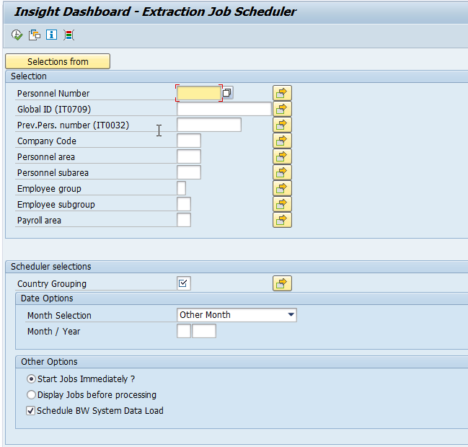

Report output

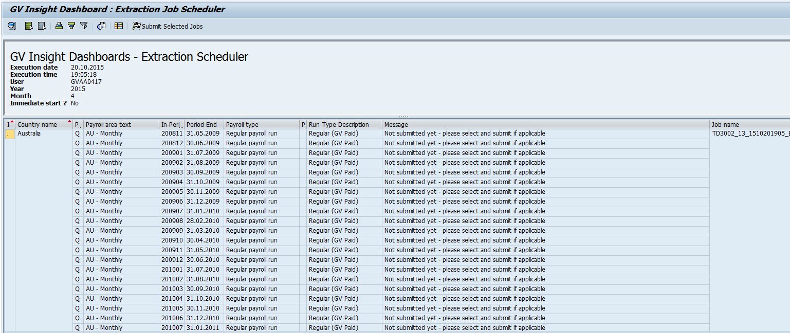

### Scheduling Extraction Job Scheduler

This program’s background job will be scheduled on (DD) of every month for the previous month. Only one job per client will be able to schedule GV Insight Dashboards extraction process for all the implemented countries of the client.

Please enter the relevant Variant for each extractor in the below section:

**Transaction : ZRADP_GID_EXSCHD**

**Program Name :** **ZR_XADP_M99_GID_SCHEDULER01**

**Variant : <implementation team must set up variant>**

Note: The Extraction program can be scheduled at any point of time during the month but it is advisable to schedule the extraction job after completing each month payroll activities.

**Implementation consultants will need to raise a CRM ticket to basis and attach the background Job request (CRM Document ID -** [**GV00004048**](https://portal211.globalview.adp.com/sap/bc/bsp/sap/zadp_viewdoc/viewdoc.htm?ID=GV00004048)**) asking for both of the above jobs to be set up.**

## Extraction Reconciliation Report

A report is made available to display the extraction data from the Extraction run and Data cluster tables, in tabular (ALV) format for export to Excel and for use in reconciliation reports / fault finding. This reconciliation report to be executed after the successful completion of the scheduled extraction program and it displays the extracted data in standard datasets format.

This is the optional step in the Data extraction process and it can used to reconcile the data extracted at period level with other payroll reports.

Transaction : **ZRADP_GID_EXREC**

This report can be executed for the selected set of employees, countries and the period. The period dates are same as the payroll period begin and end dates. The results of the specific extraction run can be displayed by entering the unique Run number generated during the extraction process.

Selection screen:

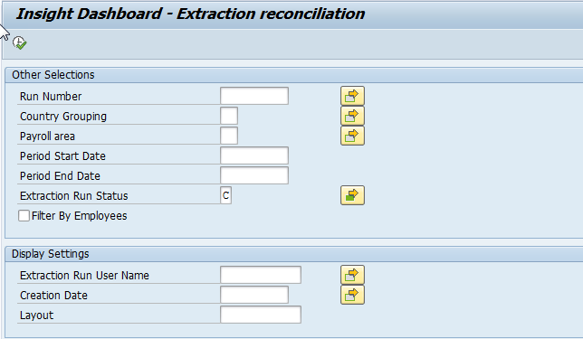

The output of the report is displayed in ALV Grid with the extraction run information and all the individual wage/SRF component values. It can be easily exported to Excel for further processing.

It displays the selected extraction run attributes in the basic screen like country, period, user employee count etc., as below.

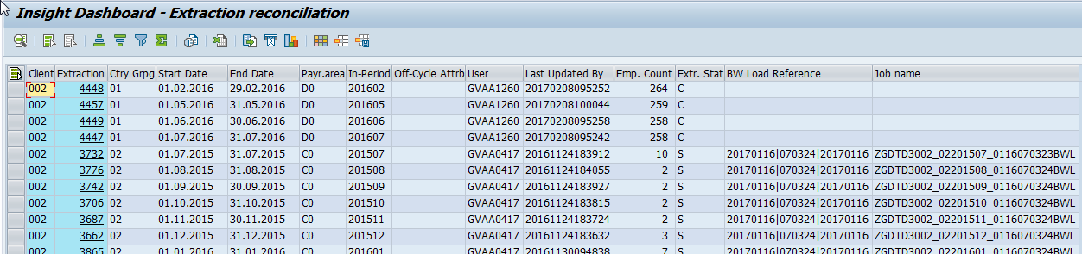

Then upon selection of specific extraction run it displays the extracted data at individual employee and wage type level.

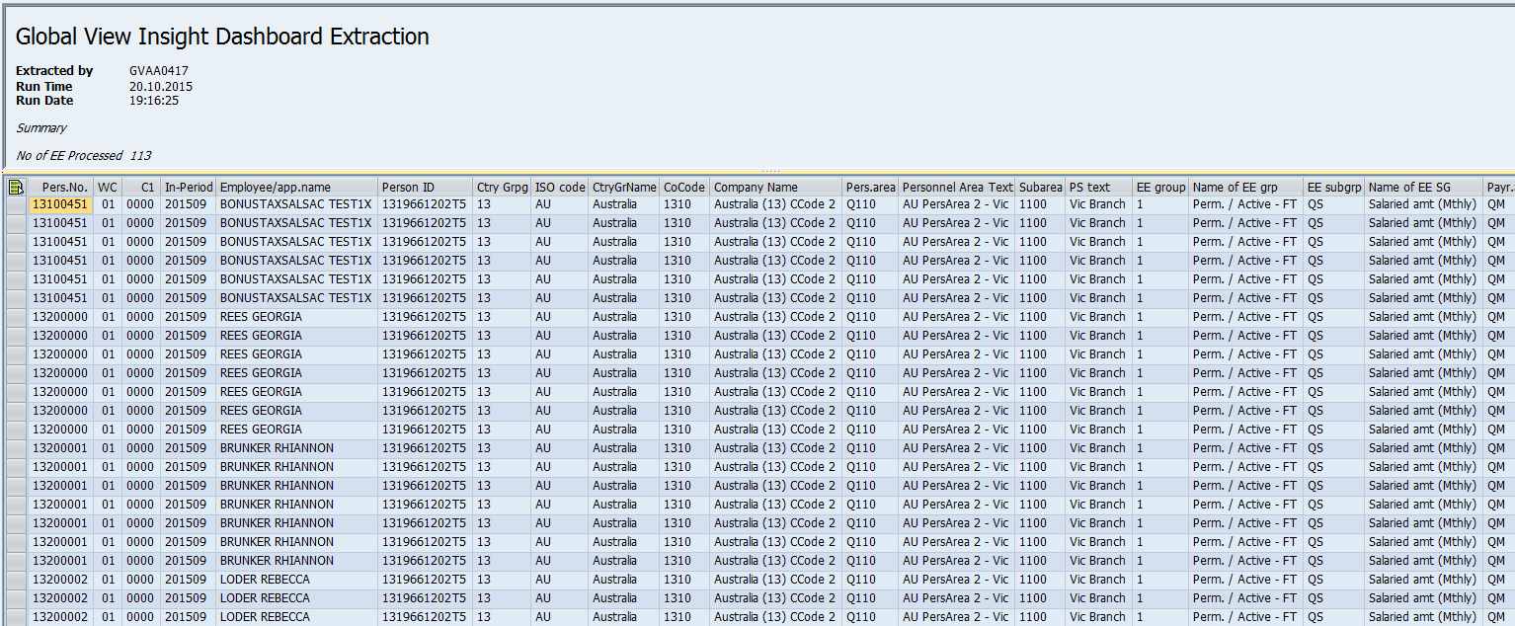

## Dashboard Tools

The utility tools made available to the Dashboards Administrators and the consultants to make the extraction reconciliation easier and delete erroneous extraction snapshots.

These can be accessed from area menu ZGVI 🡪 Tools.

### Wage Types Reconciliation

The Wagetypes to be extracted are normally mapped to the wage categories using the evaluation and cumulation classes to make it as generalized for all the clients. This utility allows in checking the individual wage types that are mapped as part of the standard setup at country level and identifying the gaps with respective to the extracted Wagetypes.

Transaction : **ZRADP_GID_WTRECON**

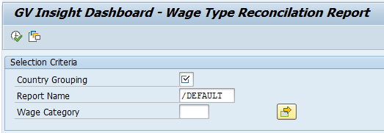

Output:

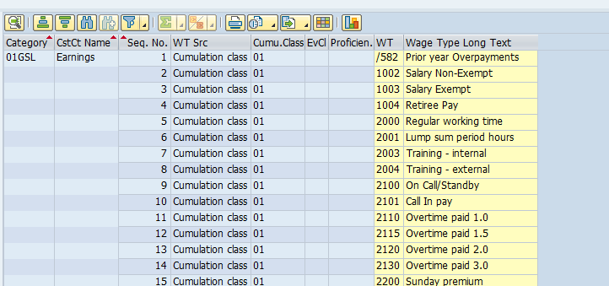

# Governance

The GlobalView Insight Dashboard application is deployed as a single application across the entire client base. It is not client-specific nor can it be developed as a client specific application. No client-specific reports will be accepted if they are submitted following the product development process.

Any template enhancements should be submitted following the Product Development Process as defined in [GV00006196 GlobalView Product Development Process](https://portal211.globalview.adp.com/sap/bc/bsp/sap/zadp_viewdoc/viewdoc.htm?ID=GV00006196).

# ITS Set-Up Tasks

For each new client implementation, the following tasked need to be completed by ITS.

Note: It is the responsibility of the implementation lead consultant to request these tasks to be completed by raising a CRM ticket and assigning it to the ITS team.

Please ensure that the following information is included in the CRM ticket so that the ITS team is aware about all the activities to be completed for the respective client.

======================================================

Please perform below Insight Dashboard related setup for client PD1/xxx.

1. Verify if the source system properly configured in BW system
2. Configure Third party logout URLs

SOP for reference: LOGI – Setup A New Client (ITS_SOP_ST_390)

======================================================

### Verify if the source system properly configured in BW system

Transaction: RSA1

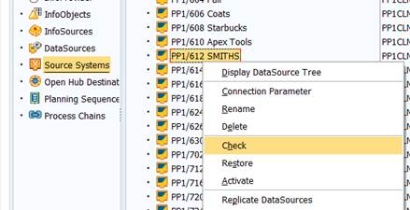

This should return similar message as below.

cid:image005.jpg@01D29114.034B36C0

### Configure 3rd Party Logout URL

As part of the set-up tasks performed by ITS, they also need to be informed to configure the 3rd party logout procedure in each system for the respective client. This is required so that the Insight Dashboard (Logi) session is closed when the user logs out of the ADP Portal.

Example:

LP1 - <https://lp1adm.ehc.adp.com/gvo_admin/adminlogin.jsp>

Logout URL: <https://portal001.globalview.adp.com/gvinsight2WP1/rdTemplate/rdEndSession.aspx>

# Responsibility Matrix

| Table | ADP | Client | Comments |
| --- | --- | --- | --- |
| ZVADP_GID_GWGTYP | No* | No | Template Wagetypes mapping |
| ZXADP_GID_GSRFCT | No* | No | SRF Components Assignments |
| ZVADP_GID_OPDSET | No* | No | Output Datasets |
| ZXADP_GID_PARAMS | Yes | No | Parameters |
| ZVADP_GID_CSFLD | Yes | No | Additional Data Fields |
| ZVADP_GID_CWGTYP | Yes | No | Client Wagetypes mapping |
| ZVADP_M99_PYPRT | Yes | No | Payroll Data Source |
| ZVADP_GID_CLDSET | No | Yes | Client Output Datasets |
| ZVADP_GID_USRAUT | No | Yes | User Authorizations |
| ZVADP_GID_COSCAT | No | Yes | Sub-categories |
| ZVADP_GID_CSTCMP | No | Yes | Sub-categories mapping |
| ZXADP_GVD_TCURR | No | Yes | Exchange Rates |
| ZVADP_GID_SUBREG | No | Yes | Regions and Sub-regions |
| ZVADP_GID_YRGRP | No | Yes | Age & Seniority Brackets |

* Denotes client independent tables that must not be changed without written consent from the Solution Architect